Gompana Melisa
melisagompana@gmail.com
EFIBM26263550864@edunetmail.com
Edu#863082
Street Vendor Digitalization Agent – using IBM Watsonx with IBM BOB
Create a new AI Agent – Street Vendor Digitalization Agent
Create a new AI Agent – a Street Vendor Digitalization Agent that helps local hawkers and micro-entrepreneurs establish a digital presence by generating business profiles, providing UPI payment setup guidance, recommending local SEO strategies, retrieving MSME schemes, and offering customer engagement suggestions using Retrieval-Augmented Generation (RAG).
Description
The Street Vendor Digitalization Agent is an AI-powered assistant built using IBM Watsonx.ai and IBM Granite models. It enables street vendors to grow their businesses digitally by creating professional business profiles, guiding them through UPI QR code setup, suggesting Google Business Profile registration, improving local search visibility, and generating promotional content.

Using Retrieval-Augmented Generation (RAG), the agent retrieves real-time information such as MSME schemes, government policies, digital onboarding procedures, geolocation-based business insights, and customer behavior trends from trusted government portals and commerce platforms.

A vendor can simply enter a prompt such as "I sell fruits in Pune Camp area." The AI agent will generate a business profile, UPI QR code setup guide, Google Business Profile recommendations, local SEO strategies, MSME scheme suggestions, pricing recommendations, promotional content, and customer engagement tips.

This AI-powered solution helps informal businesses increase their digital visibility, improve customer reach, and access government support programs.
Tools & Technologies Used
IBM watsonx.ai
IBM Granite Models
IBM Cloud Lite
IBM BOB
Python Flask
Retrieval-Augmented Generation (RAG)

Step-1 login with your credential on IBM cloud.
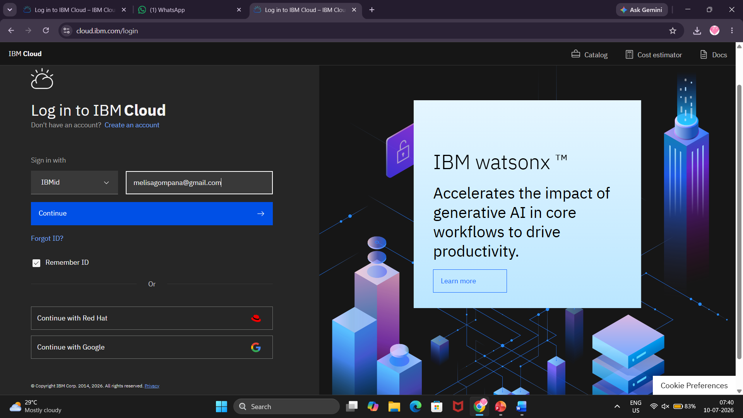
Step-2 go to search bar and search watsonx.ai.studio .
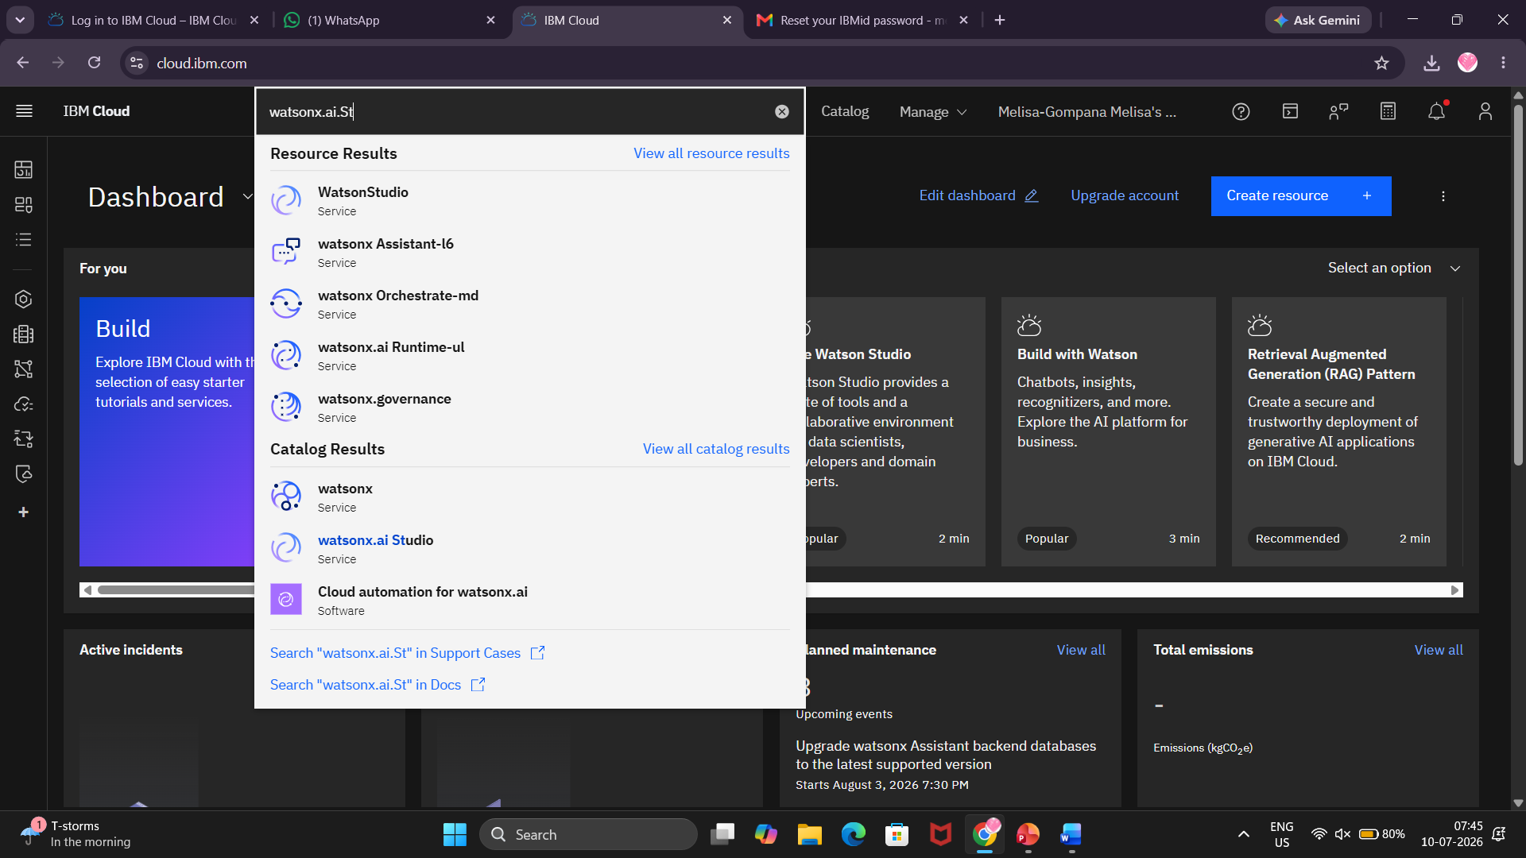
Step-3 create watsonx service select location as Sydney go with free plan and mark checkbox and create.
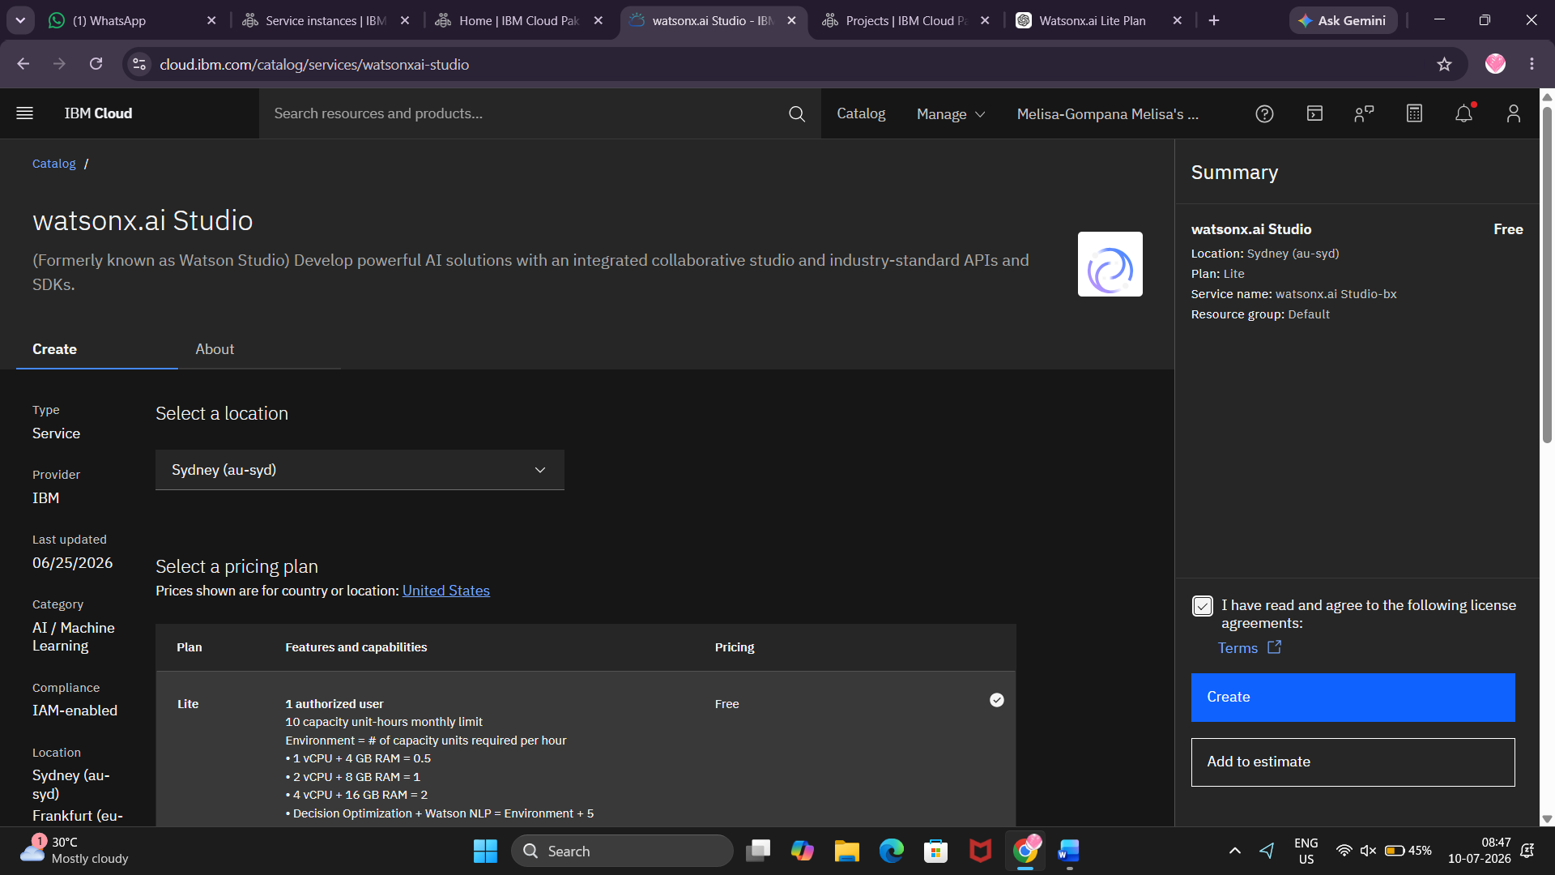

Step-4 click on launch in button
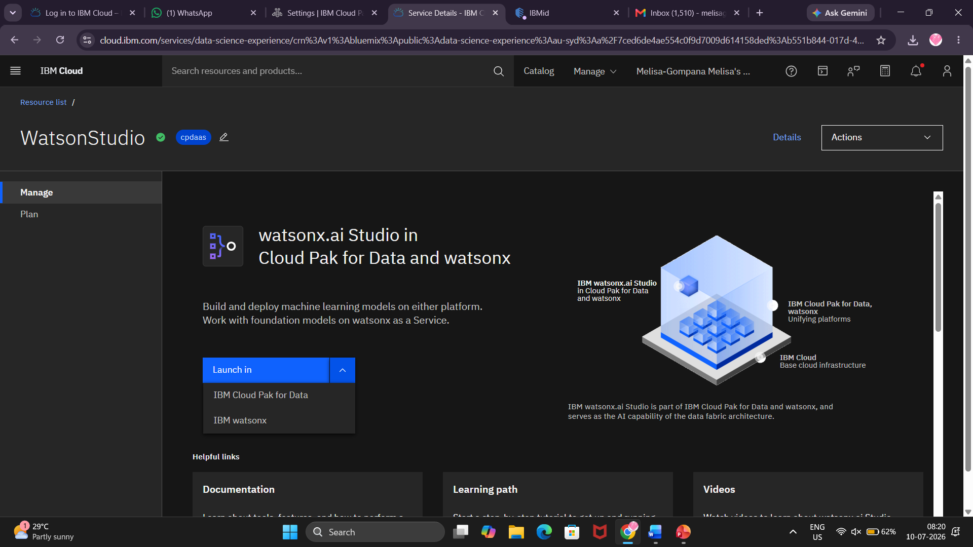

Step-5 Select watsonx runtime and click on next.

Step-6 select location and click on create

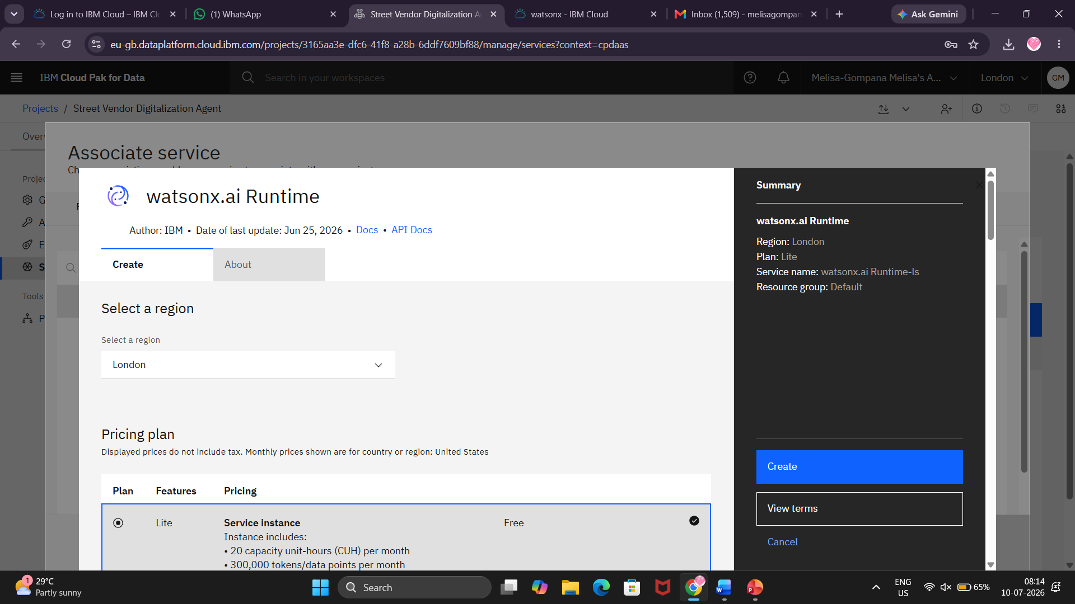

Step-7 Select New project and click on next.

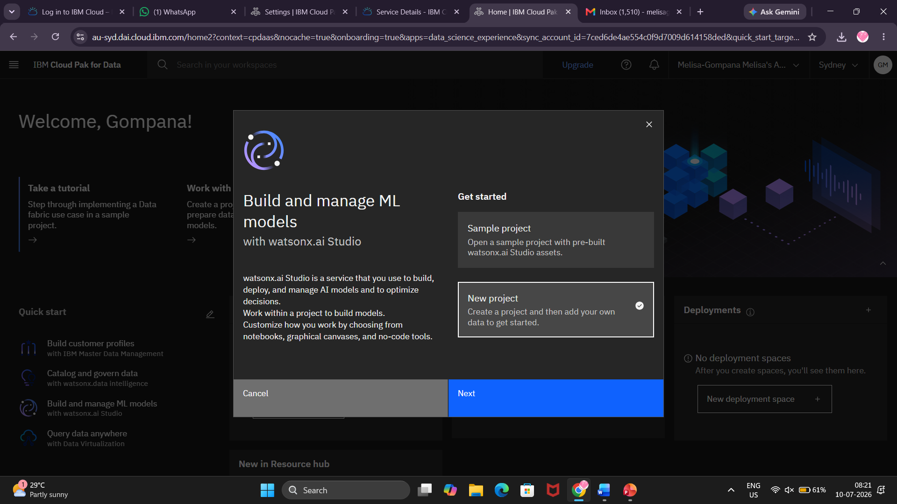
Step-8 give name to your project and click on Create key.
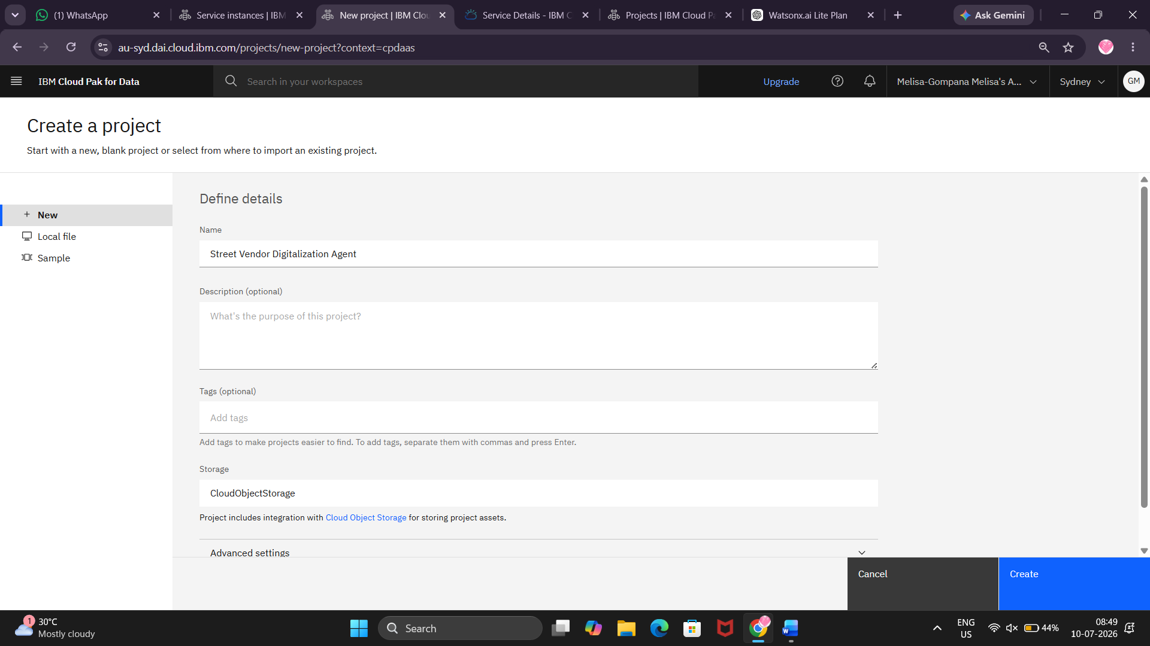
Step-9 click on create

Step-10 go to manage
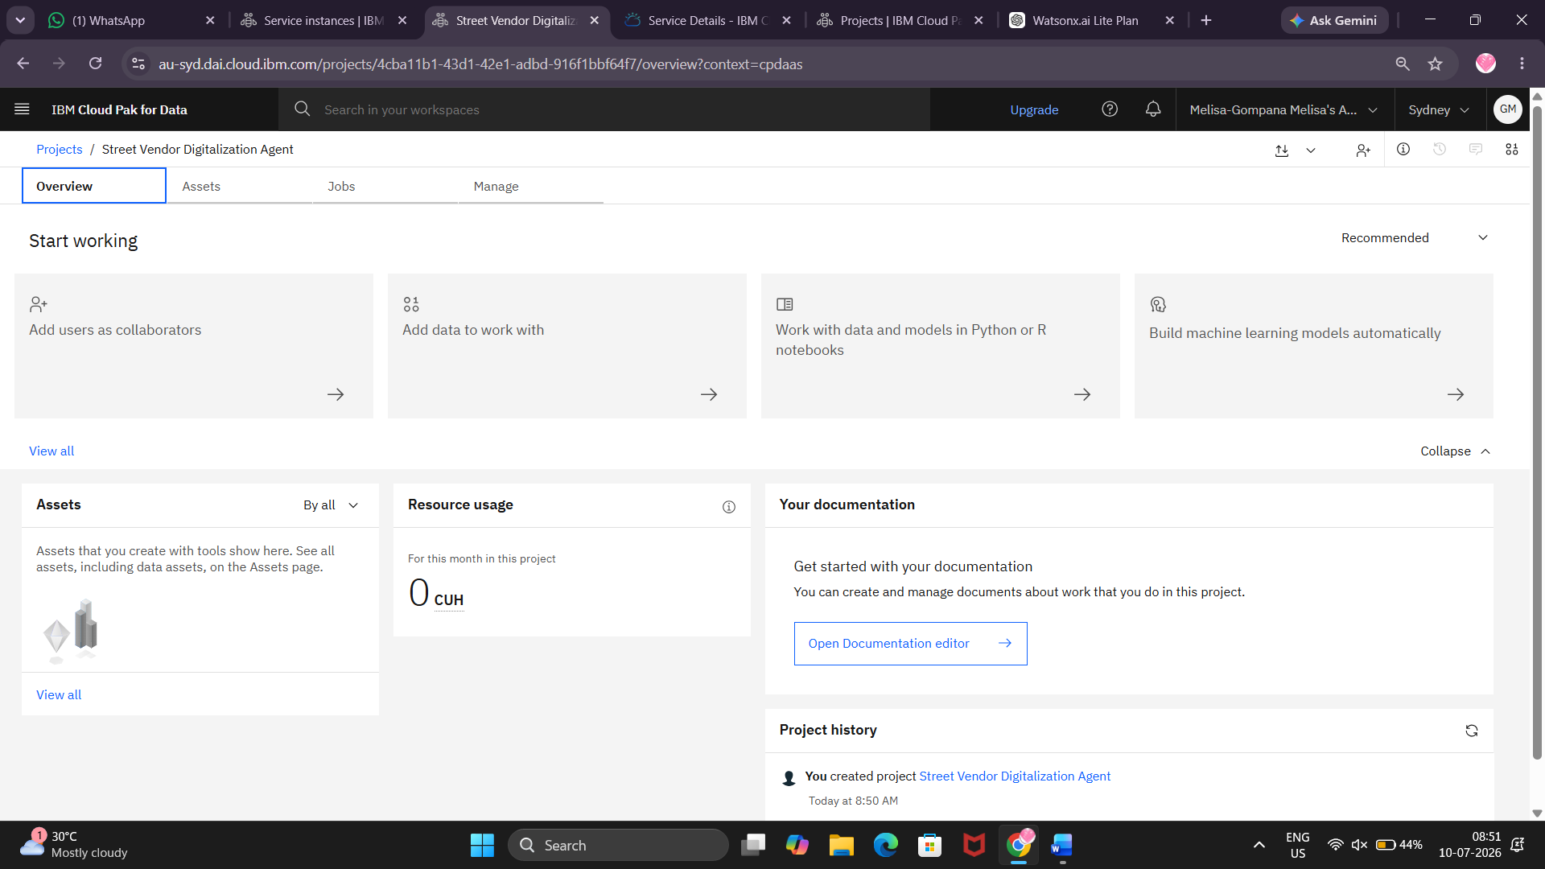
Step-11 click on services & integration.
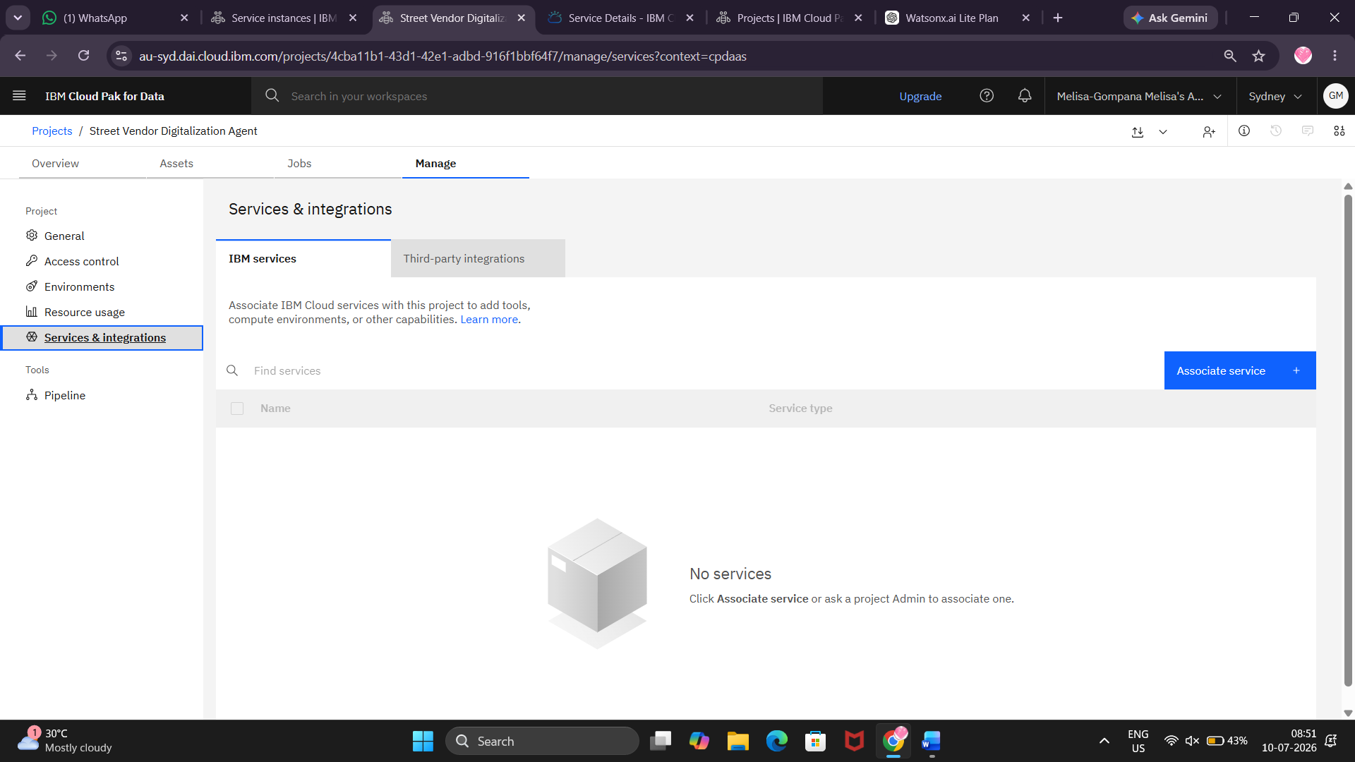
Step-12 click on Associate Service.

Step-13 mark the checkbox.

Step-14 click on create.
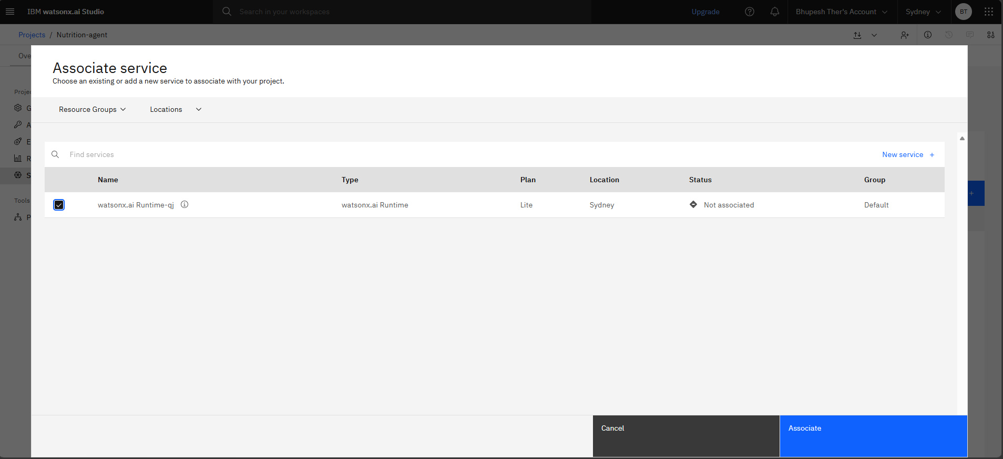

Step-15 Come to general and copy project ID and paste in your notepad.
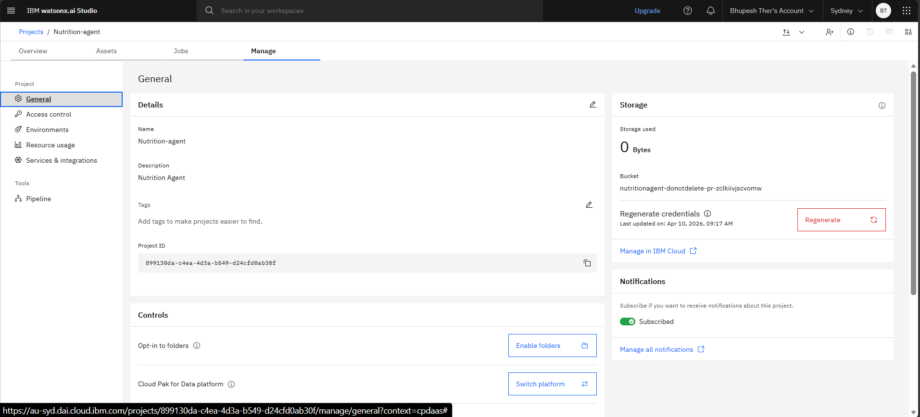

Step-16 Click on previous tab
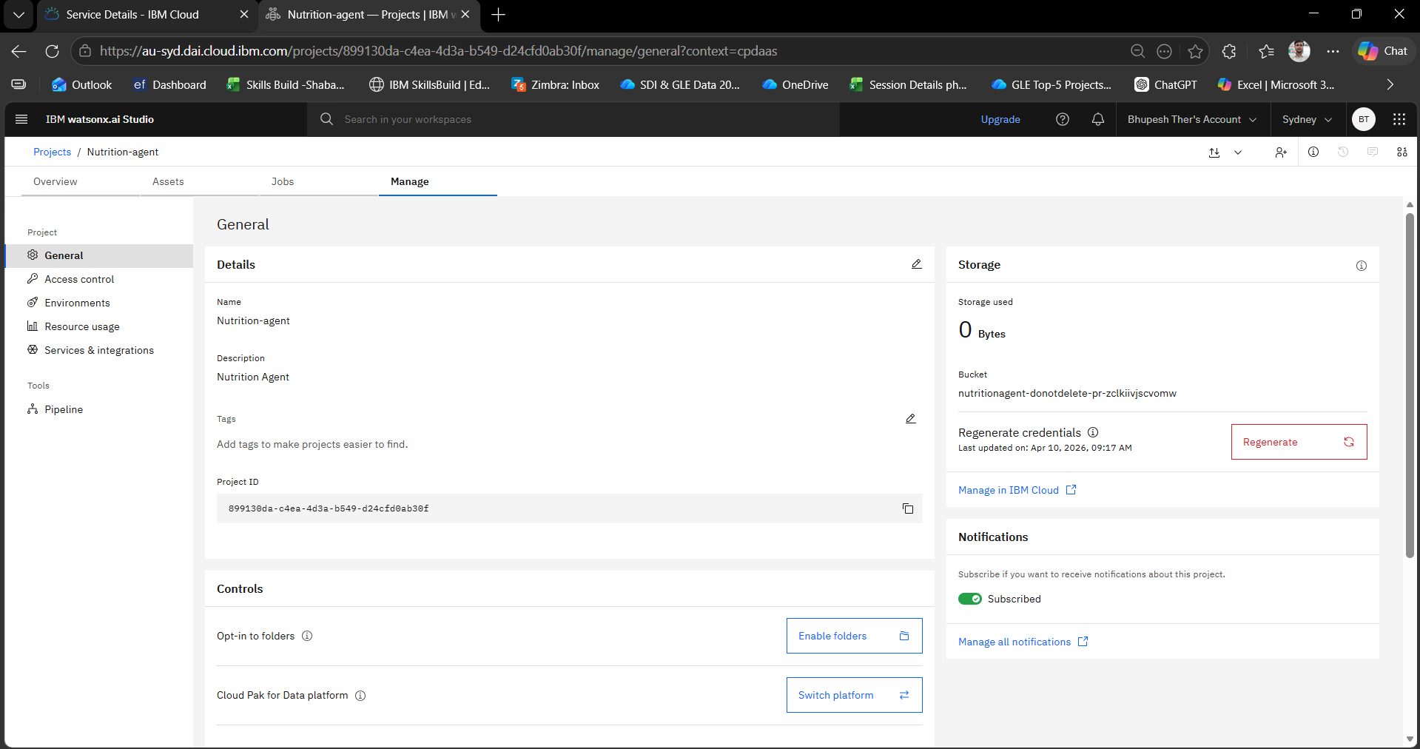
Step-17 click on Access(IAM).
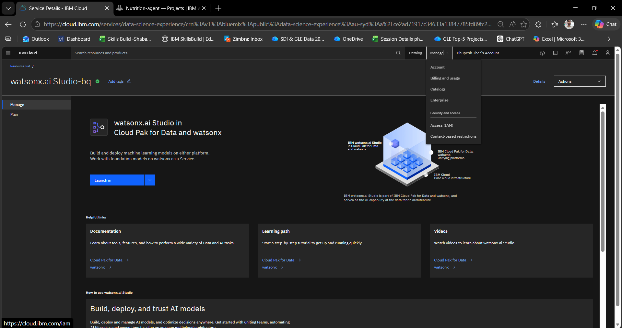

Step-18 click on API keys
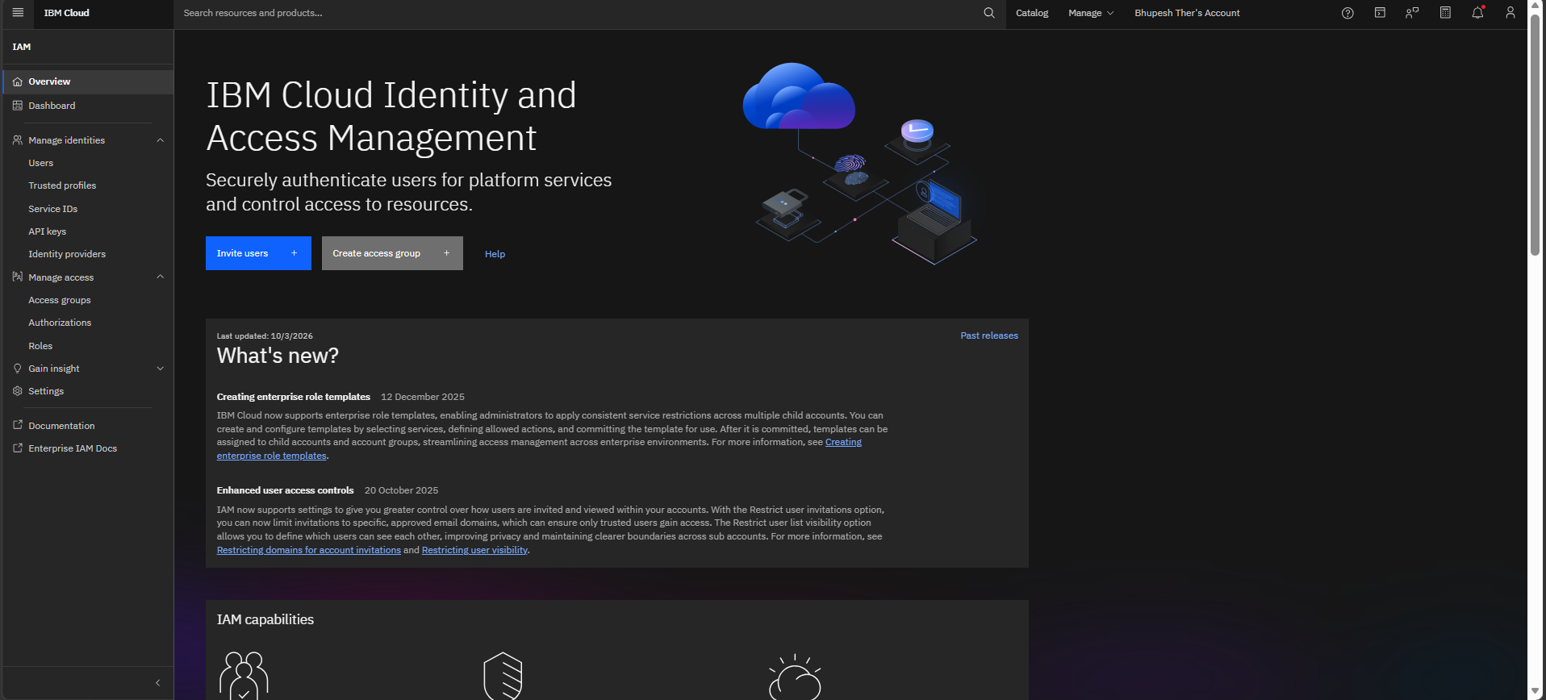

Step-19 click on create button
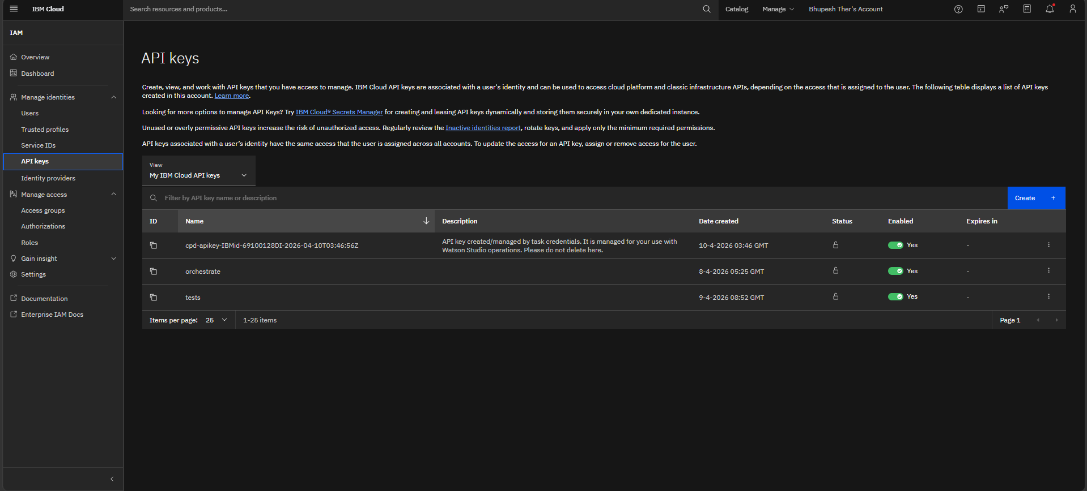
Step-20 give name to your api-key and click on create.
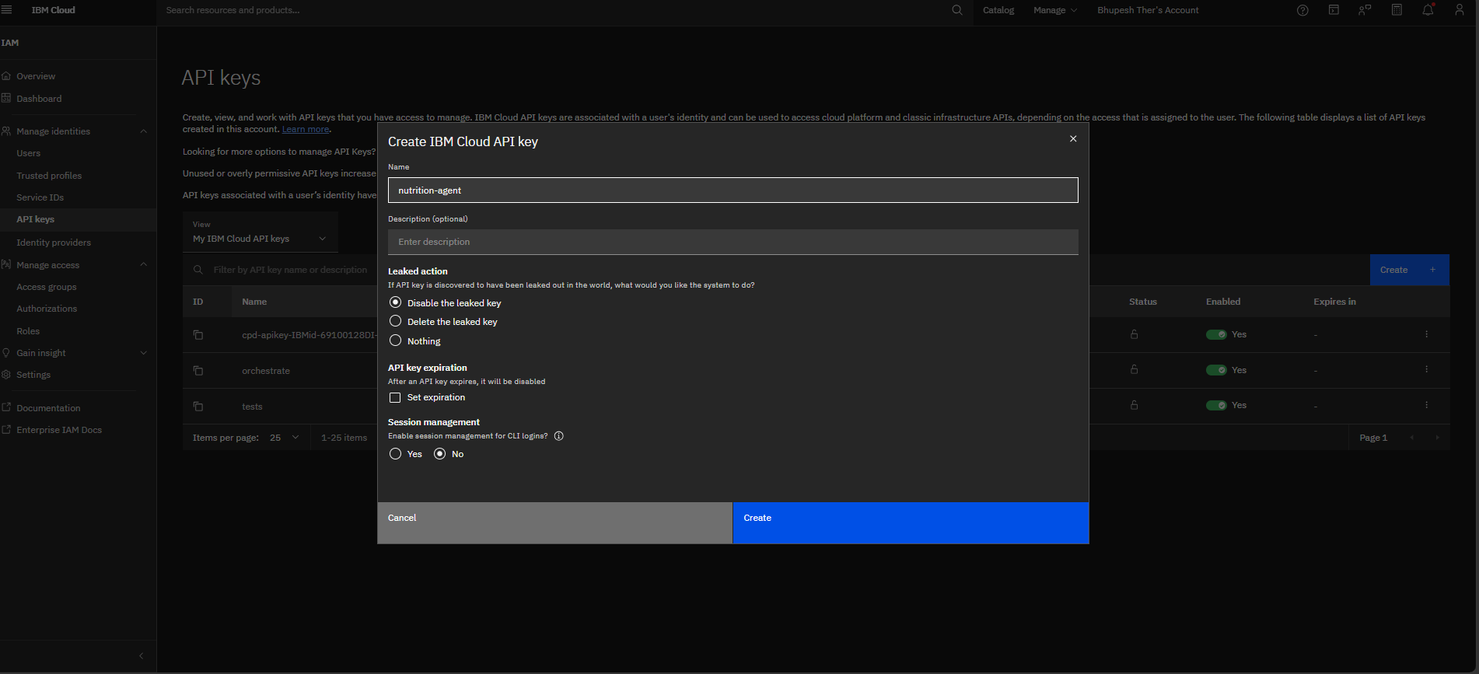

Step-21 Copy your api-key and paste in your notepad.
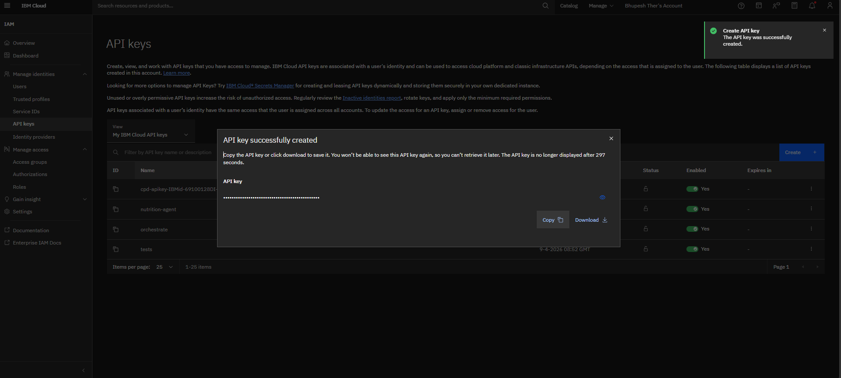

Step-22 Open IBM BOB.
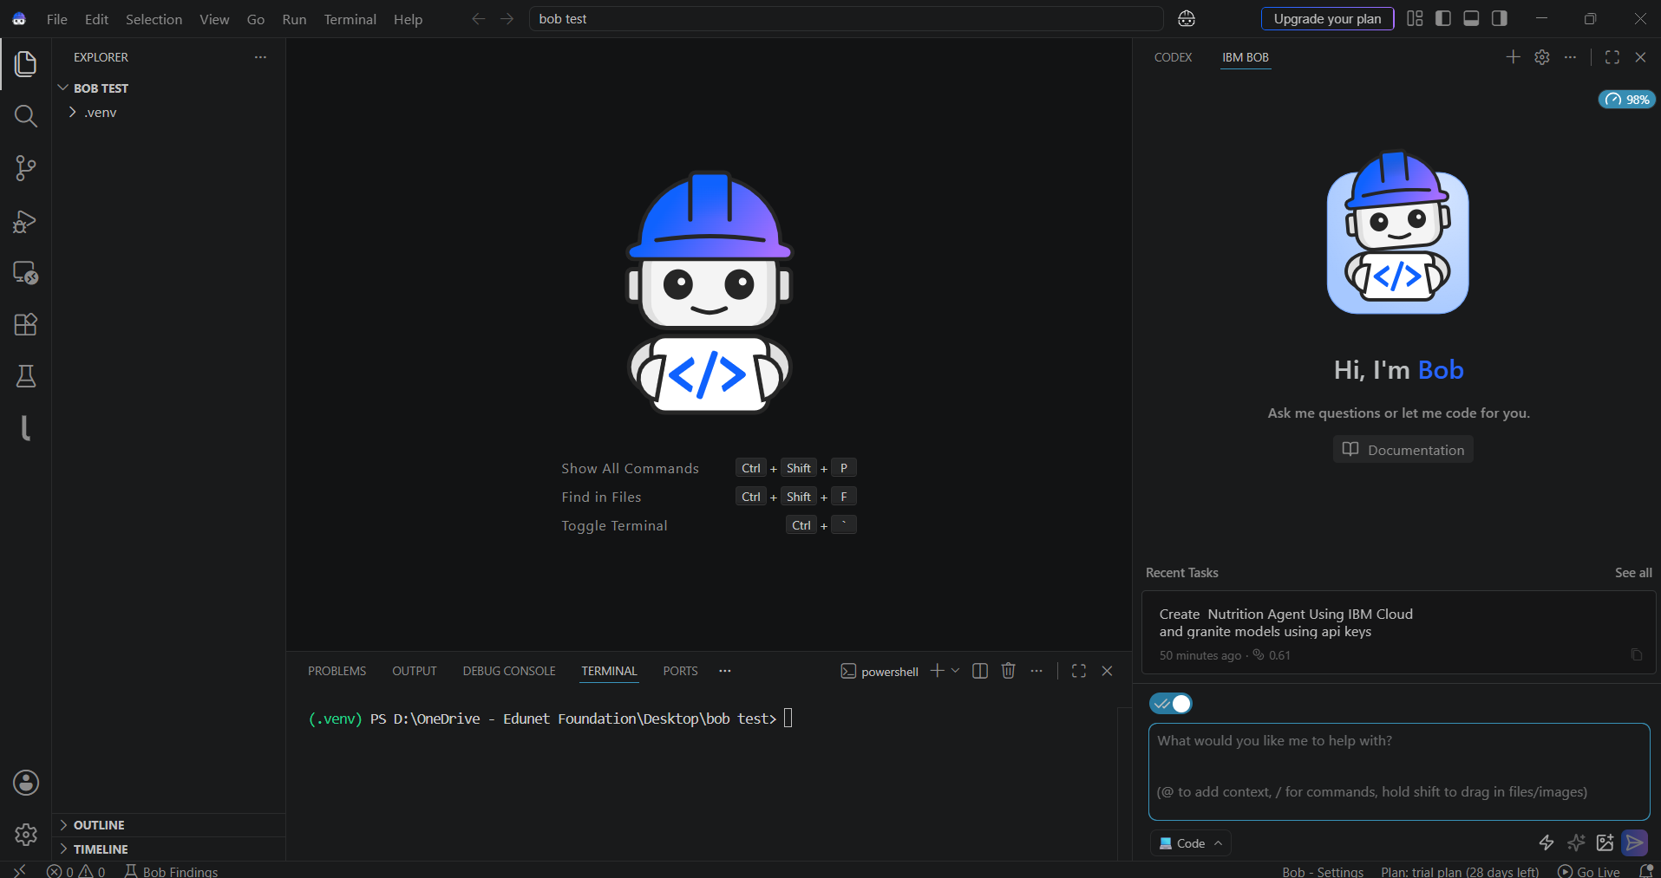
Step-23 Give Prompt to your agent.
Prompt-
Create an AI-powered Street Vendor Digitalization Agent web application using Python Flask and IBM Watsonx.ai with IBM Granite models. Integrate the IBM Cloud API Key securely using a `.env` file and build a modern, responsive web application with an attractive chat interface and vendor dashboard.

The application should use Retrieval-Augmented Generation (RAG) to retrieve real-time information from government portals, MSME websites, fintech platforms, and commerce resources. Add an `AGENT_INSTRUCTIONS` section so the agent's behavior, response style, language, safety rules, and business recommendations can be easily customized.

The Street Vendor Digitalization Agent should provide the following features:

• Generate professional business profiles for street vendors and micro-entrepreneurs.
• Provide step-by-step UPI QR code setup guidance for digital payments.
• Recommend Google Business Profile registration and local online listing platforms.
• Generate Local SEO strategies to improve business visibility in nearby areas.
• Retrieve real-time MSME schemes, government policies, subsidies, and financial assistance programs using RAG.
• Suggest pricing strategies based on product category and local market conditions.
• Recommend digital marketing ideas, promotional offers, and customer engagement strategies.
• Generate promotional posters, business descriptions, and social media content.
• Provide multilingual responses (English, Hindi, Telugu, Marathi, Tamil, etc.).
• Offer digital onboarding guidance for first-time vendors.
• Maintain conversation history and personalized vendor profiles.
• Include a responsive Bootstrap-based frontend with animations, dark mode, and mobile-friendly design.

Generate the complete backend, frontend, RAG integration, vector database setup, requirements.txt, .env configuration, project structure, and deployment instructions. Ensure the application is compatible with IBM Cloud Lite services and IBM Granite foundation models.
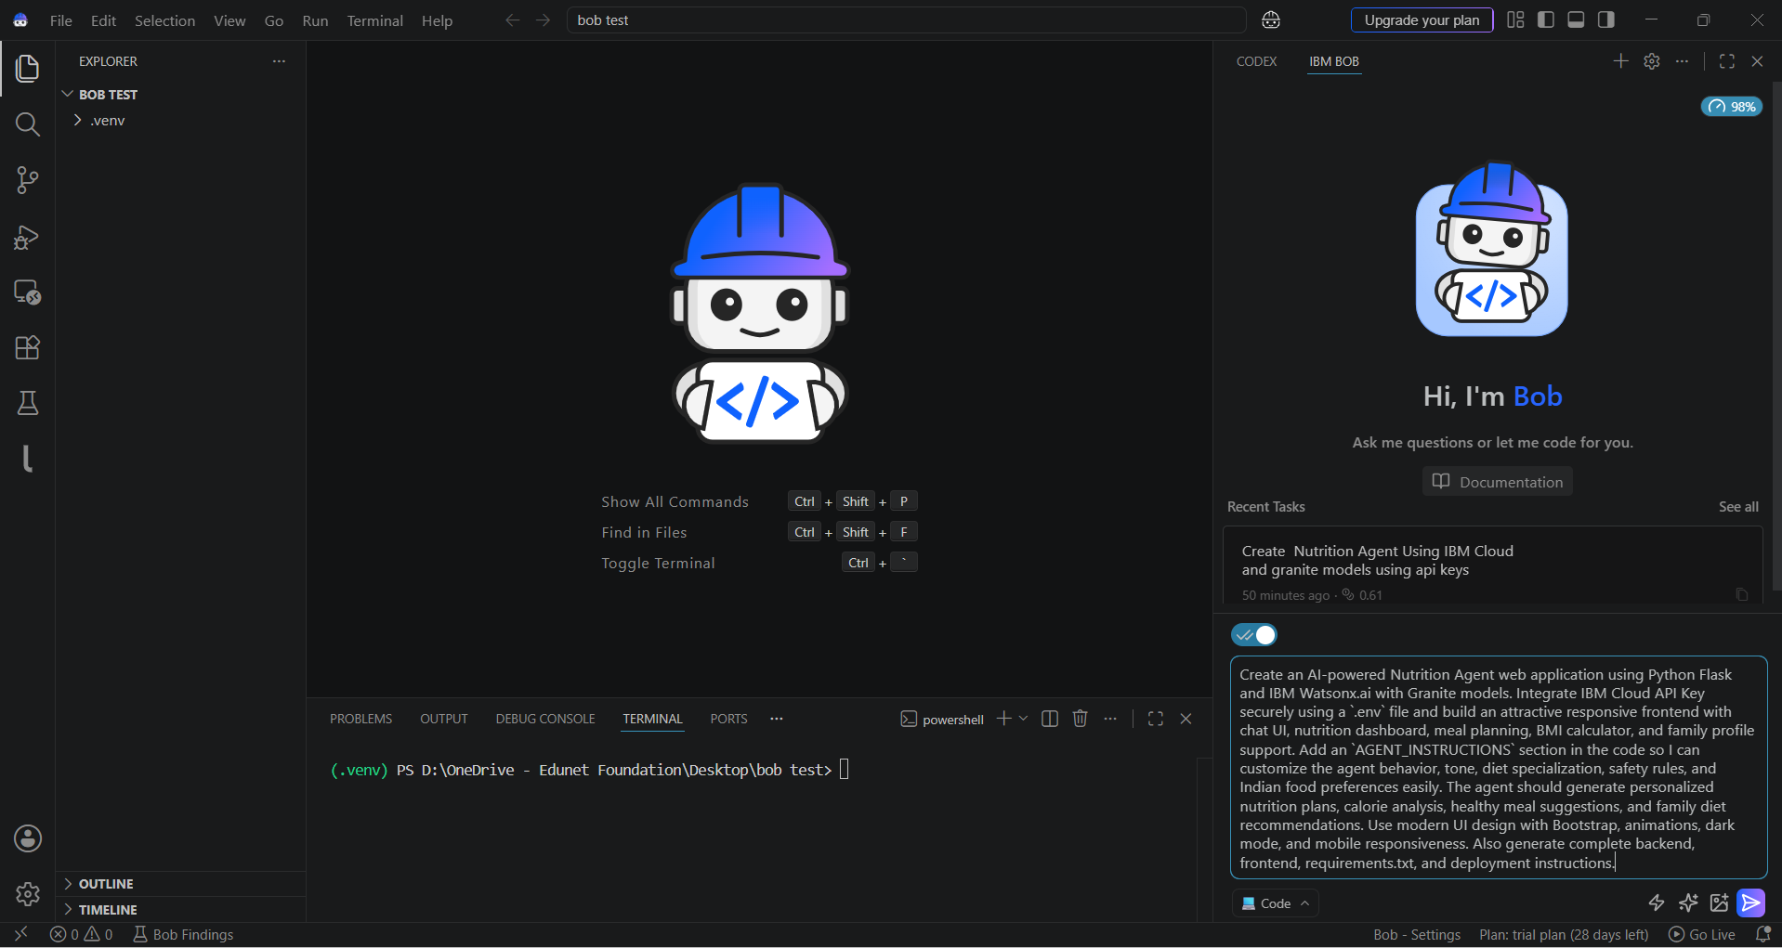

Step-24 Approve the plan created by BOB Agent
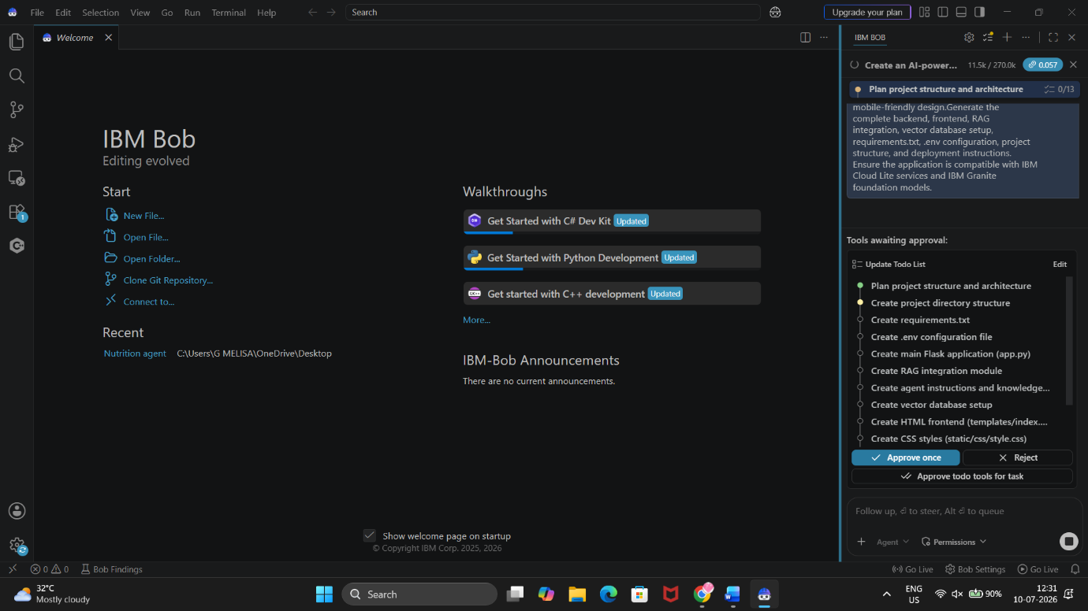

Step-25 Save the code give by BOB.
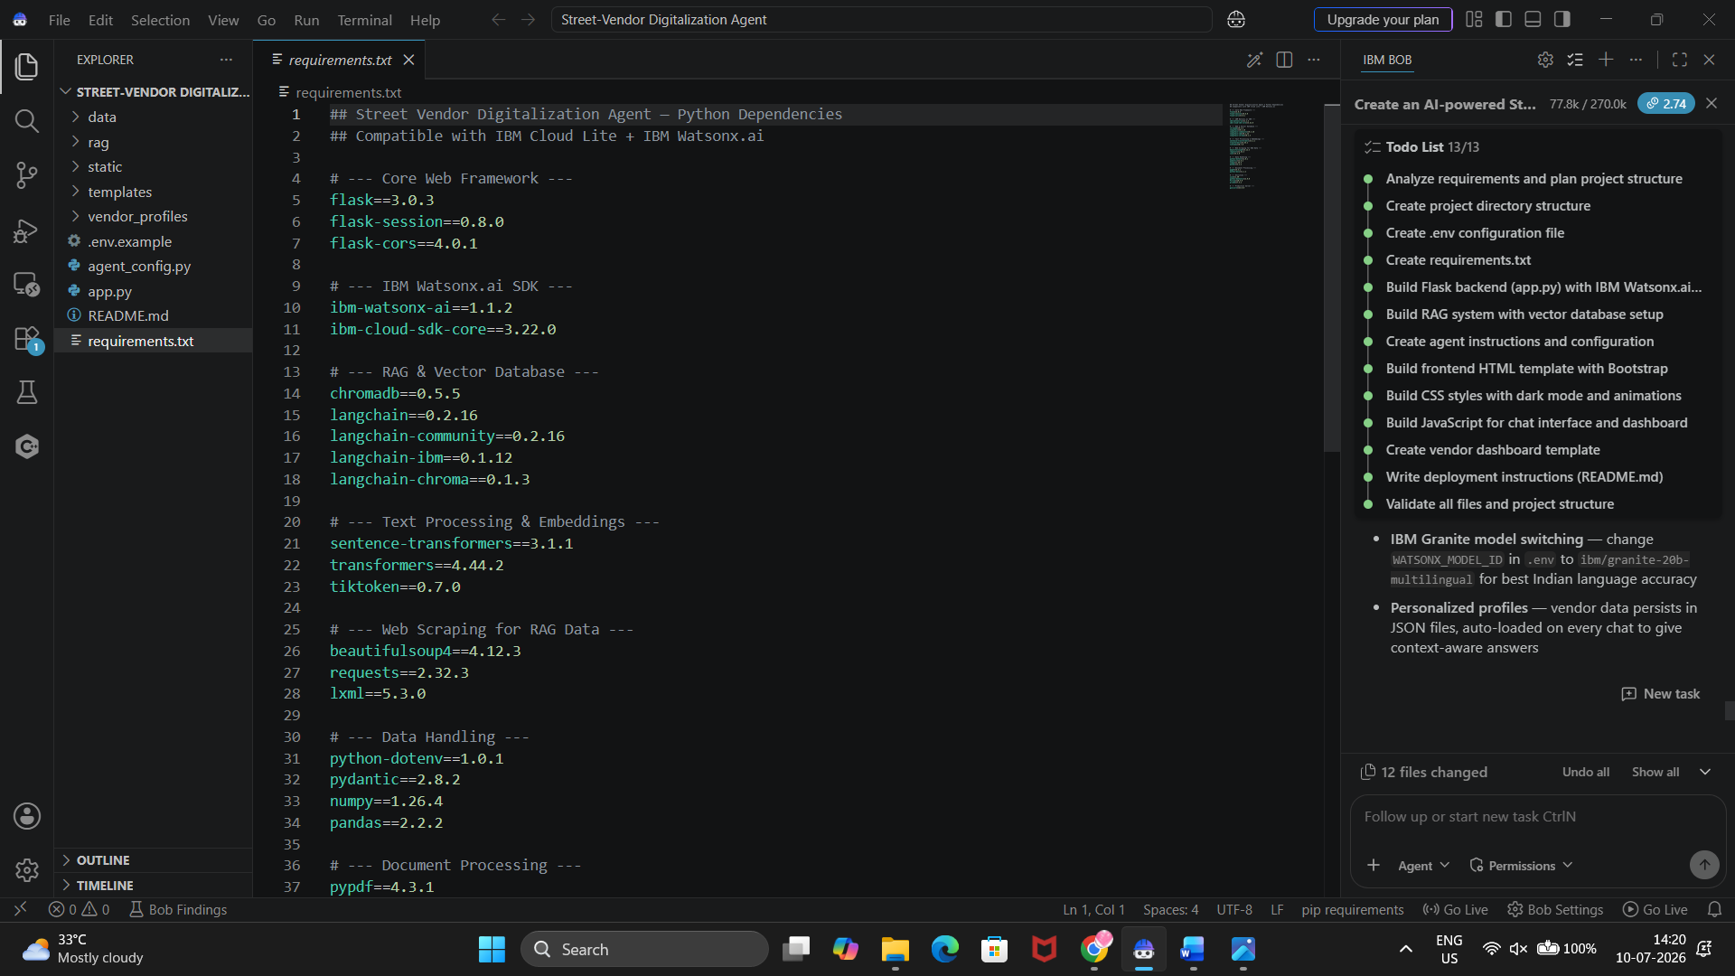
Step-26 It will create code form the scratch.
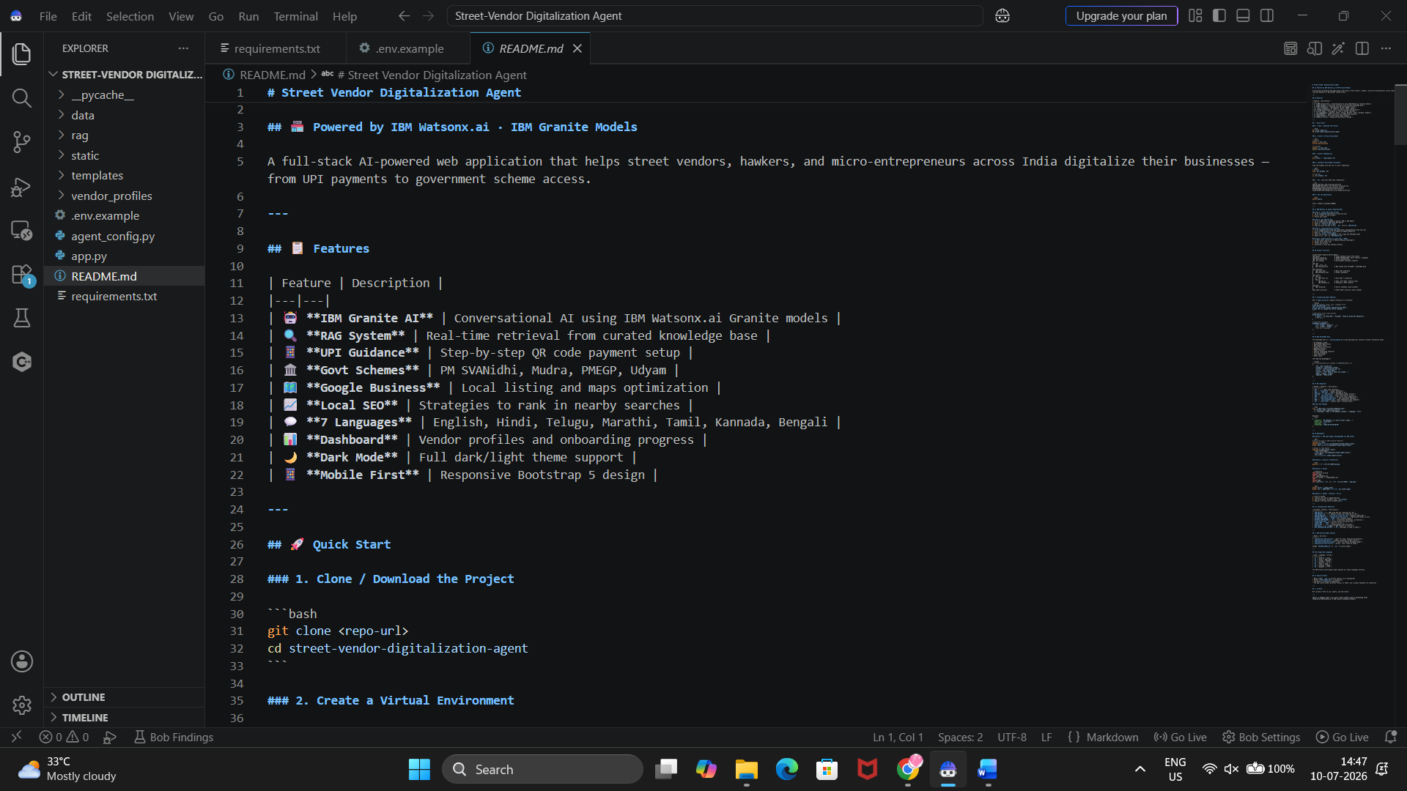
Step-27 once All file created approve for guideline and Now install All libraries in your system using UV.
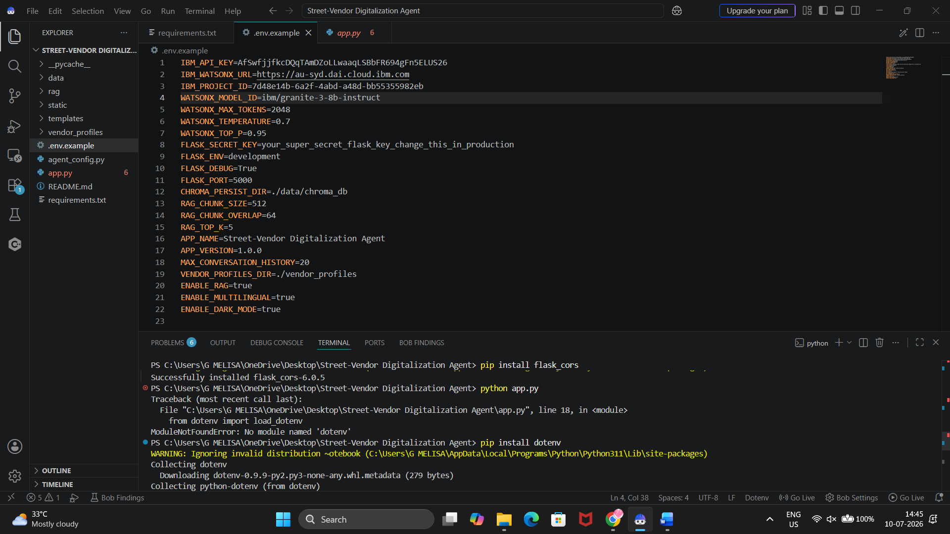
Step-28 Add your API Key ,Project ID , IBM URL and Model Name in .ENV file.
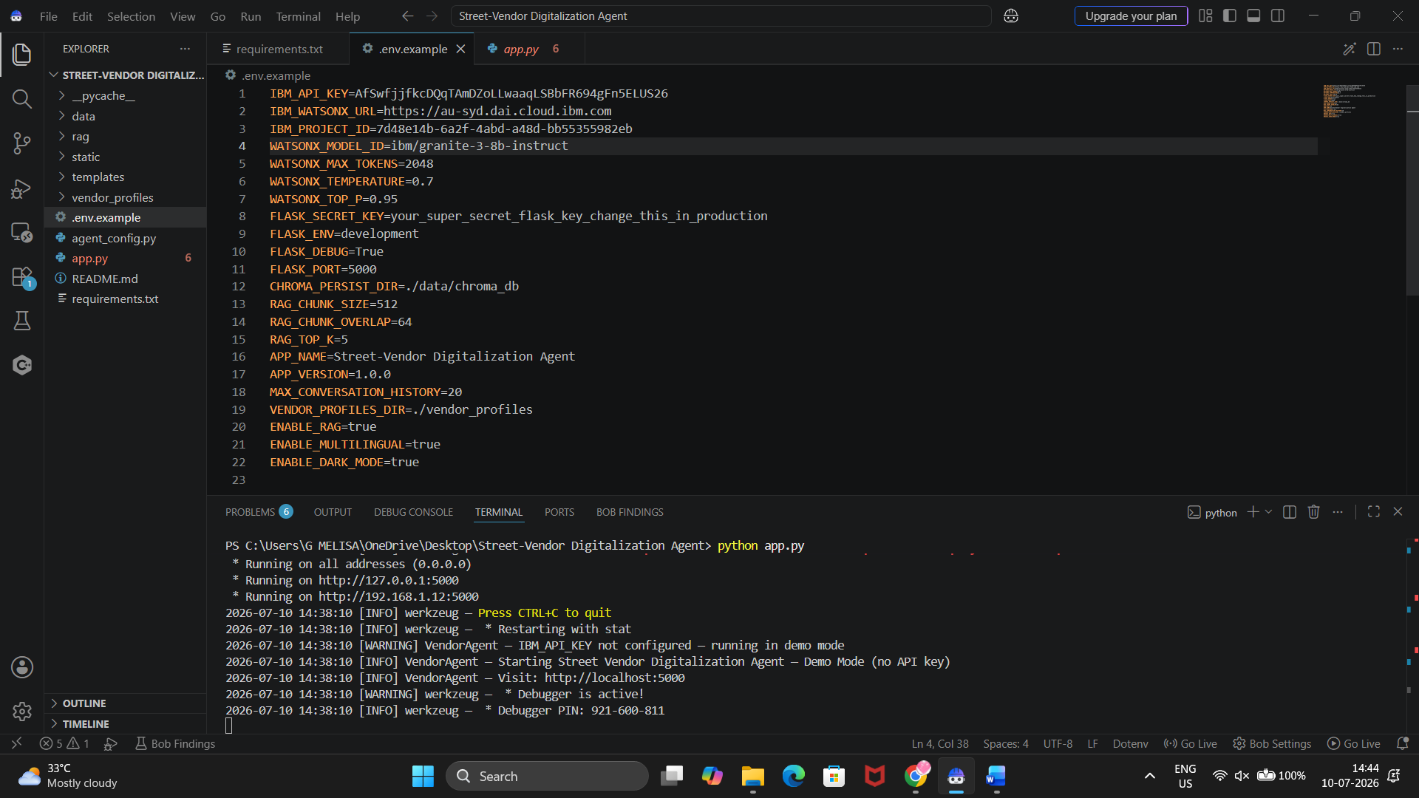
Step-29 Change URL Link and Model name From App.py .
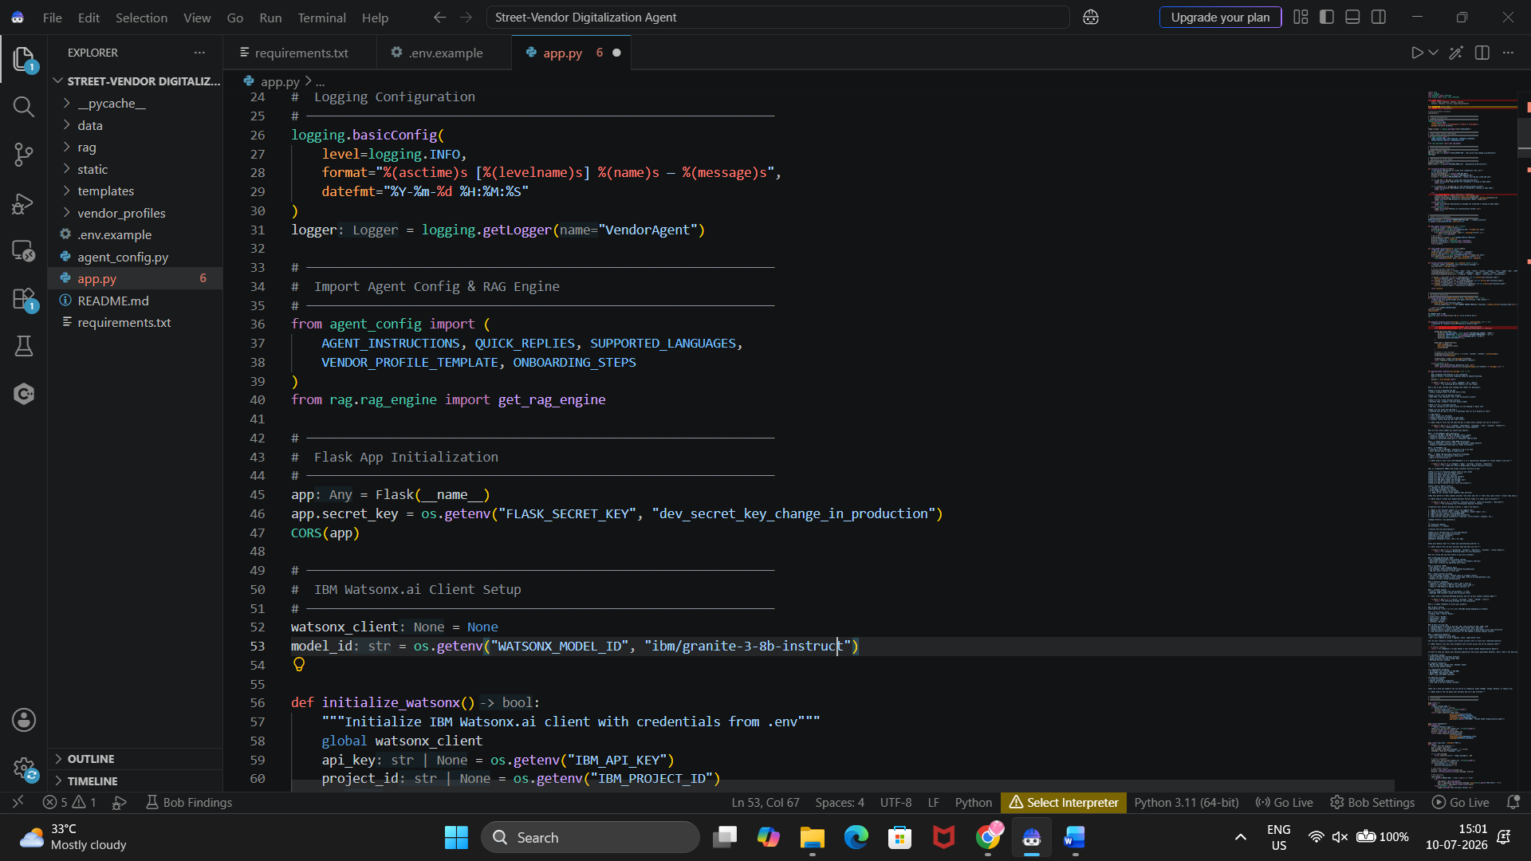
Step-30 Run this Project Using Below Link And Click on Local Host URL
UV run app.py
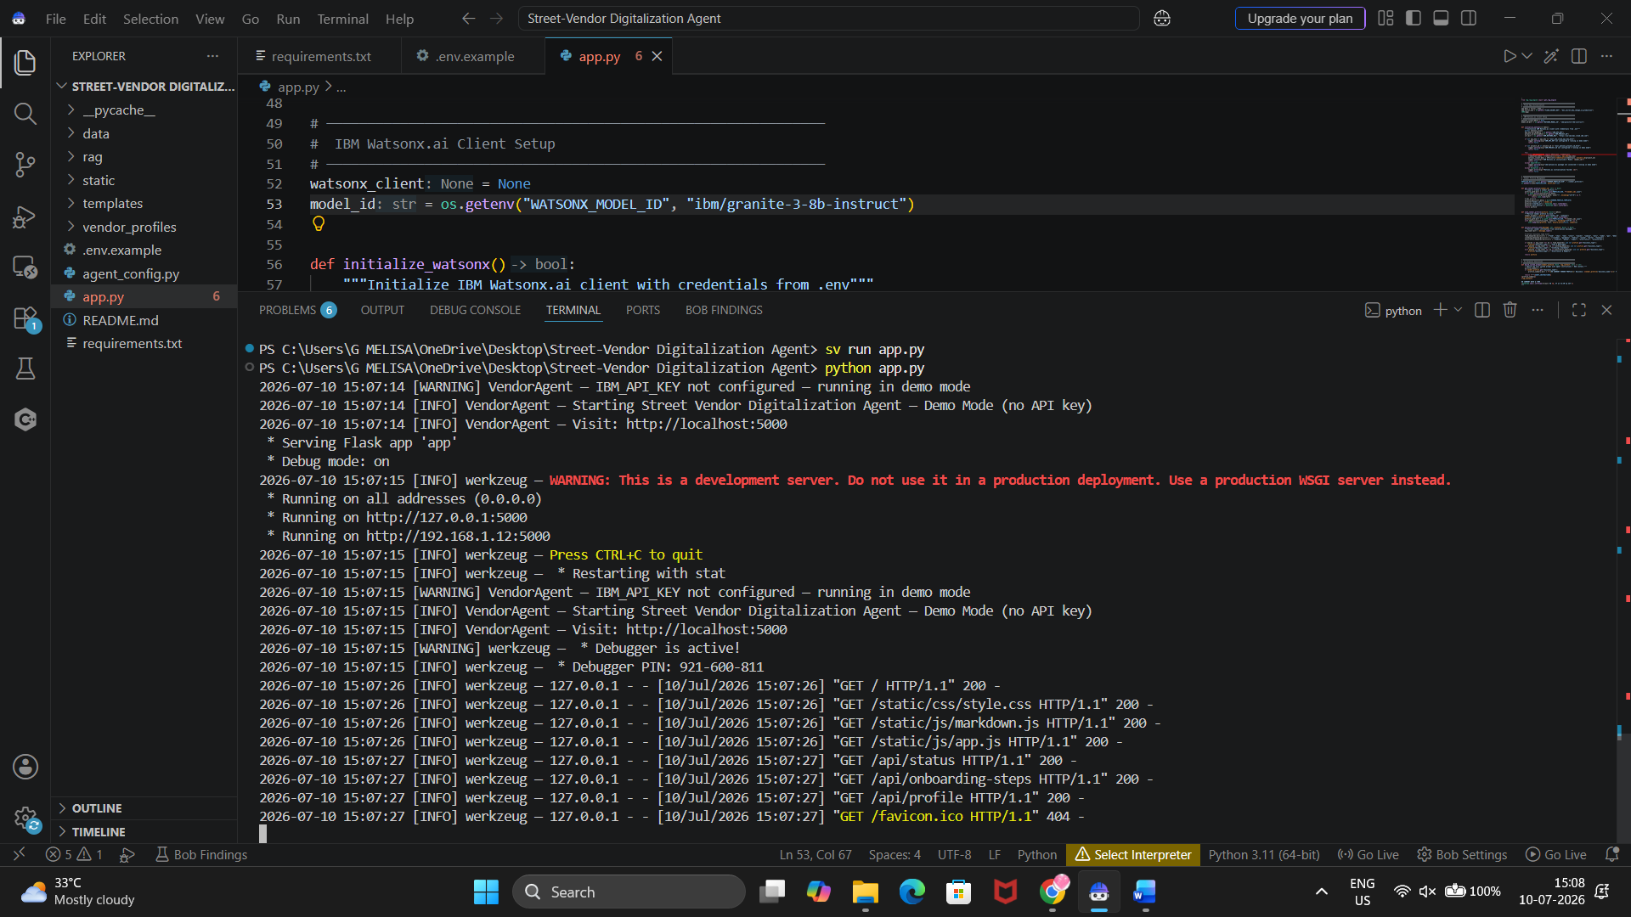
Step-31 check Website create by BOB.
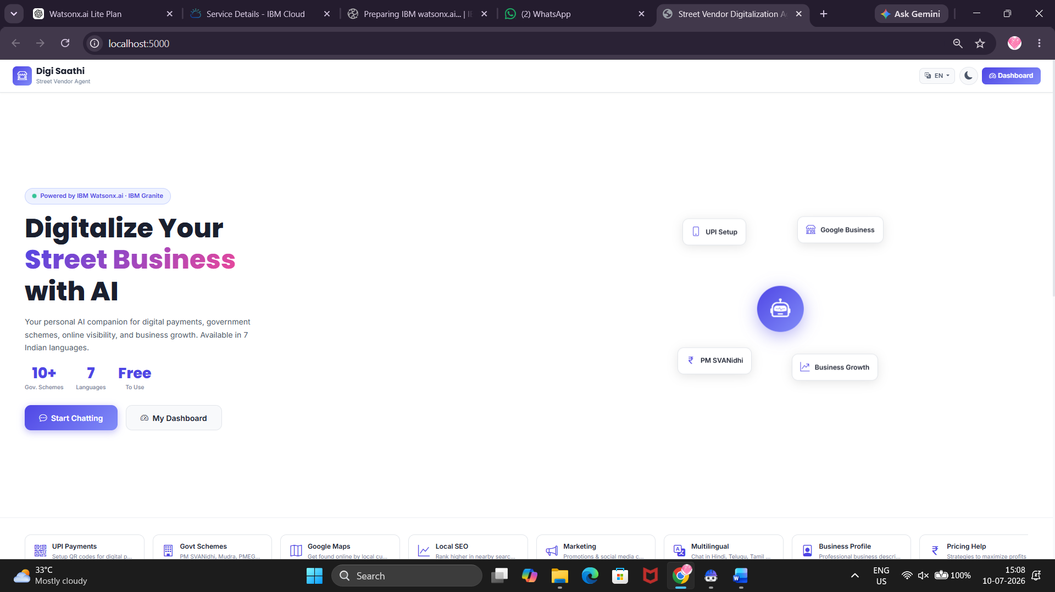
Step-32 Give Prompt and test your Agent

Hi Digi Saathi! I am Ramesh, a 32-year-old street vendor from Visakhapatnam, Andhra Pradesh. I sell fresh vegetables from a roadside cart near the RTC Complex. I have been running my business for 5 years. My average daily sales are around ₹3,500, and my monthly income is about ₹45,000. I currently accept only cash payments and do not have a UPI QR code. I have never registered my business with Google Business Profile or Udyam (MSME). I also want to know if I am eligible for government schemes such as PM SVANidhi and Mudra Loan. Please help me:
- Create my business profile.
- Explain how to set up UPI payments.
- Tell me how to register on Google Business Profile.
- Check my eligibility for PM SVANidhi and Mudra Loan.
- Suggest a pricing strategy to increase my profits.
- Recommend ways to promote my business on WhatsApp and social media.
- Give me tips to increase my daily sales to ₹5,000.
- Explain everything in simple English.
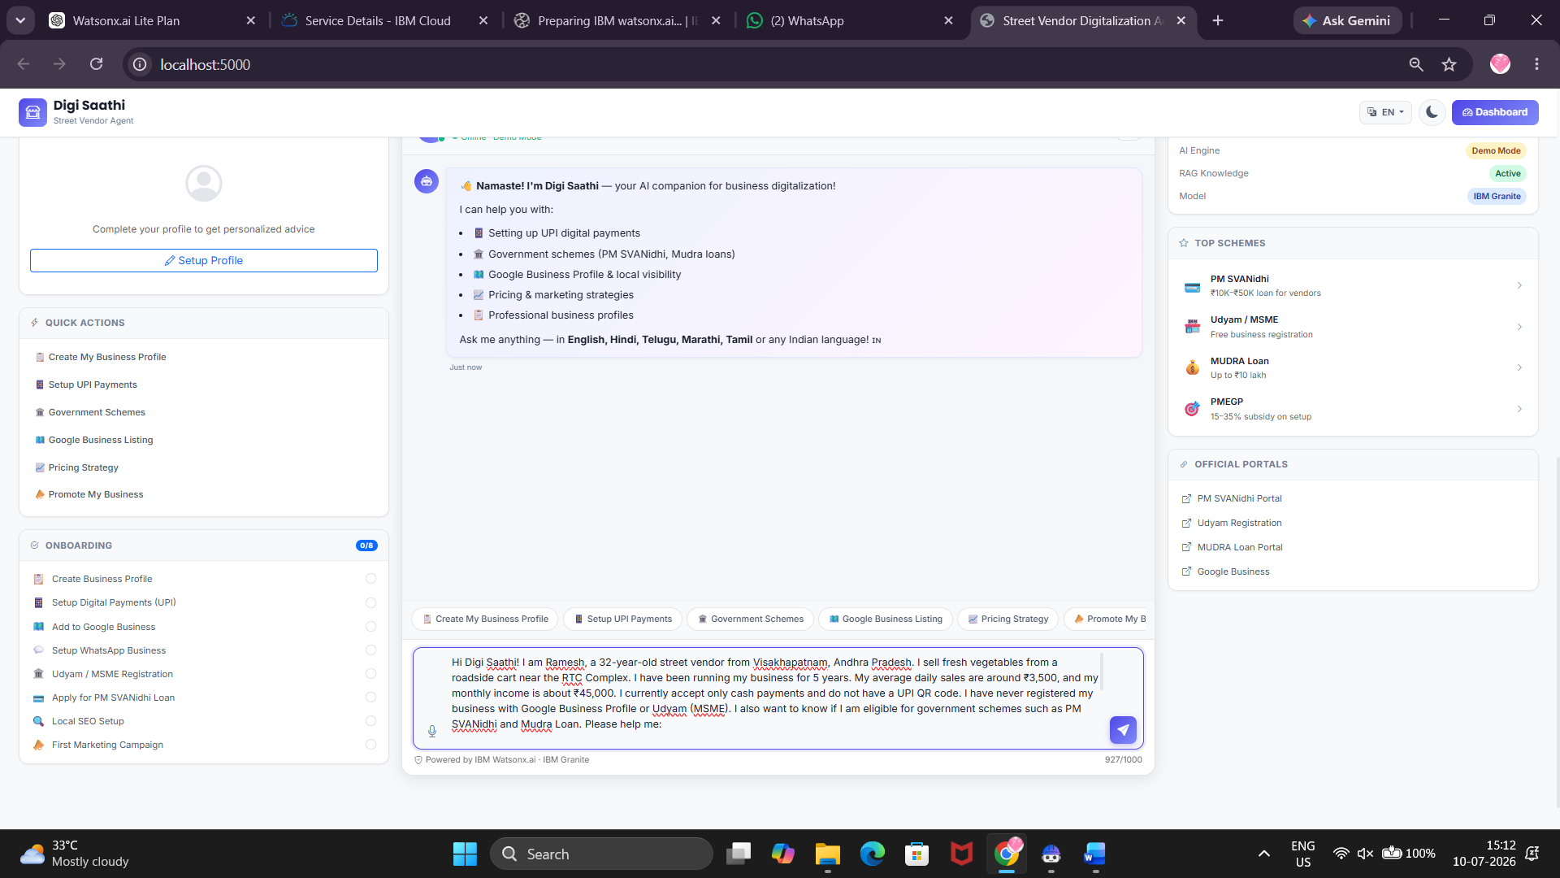
Step-33 Check the Output.
